The title page frame is the first frame of this game. It has a start, instructions, leaderboard and exit button.

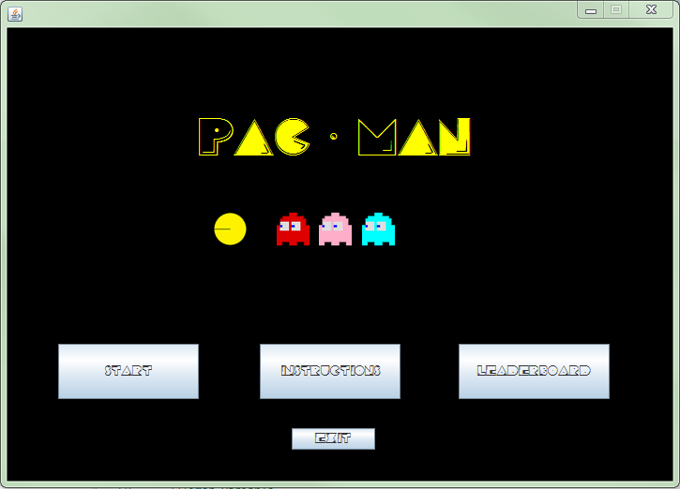

When the leader board button is pressed, the leader board will open showing past scores. The leaderboard contains a sort by and search combo box. These allow you to sort each column from highest to lowest. Also the search text field and button allow you to search for data in each section of the leaderboard.

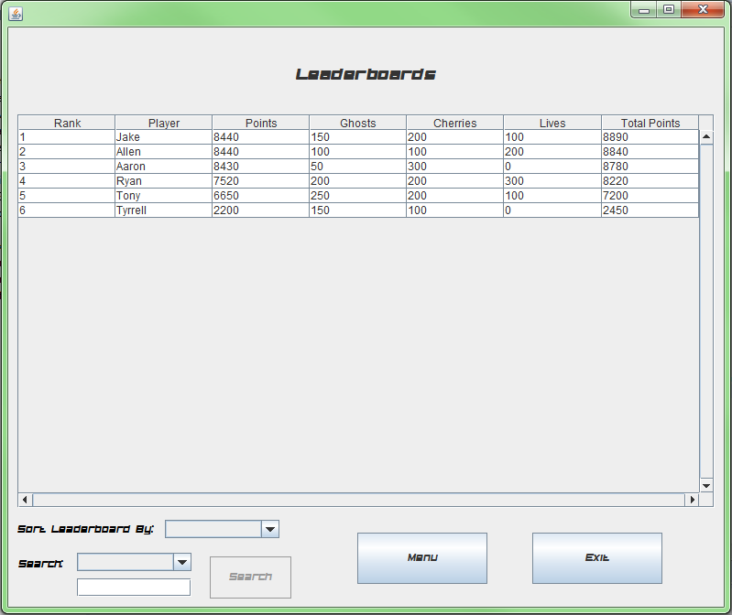

When the menu button is pressed it will bring you back to the menu.

When the Instructions button is pressed on the menu, the instructions frame will open and the title page frame will close. The Instructions frame includes a start, menu and exit button.

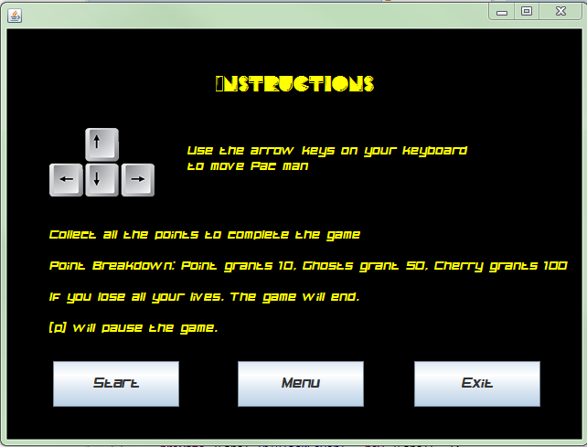

If you press the menu button it will bring you back to the menu

When the start button is pressed in the title page frame or instructions frame you will be asked to enter your name.

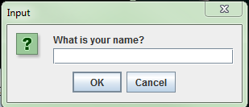

Once you’ve entered your name then the loading page frame will open. The loading frame contains a menu, start and exit button.

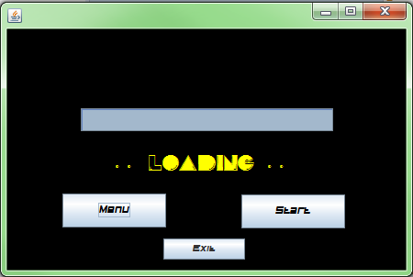

The menu button will bring you back to the menu.

The start button will close the loading page and start the game applet.

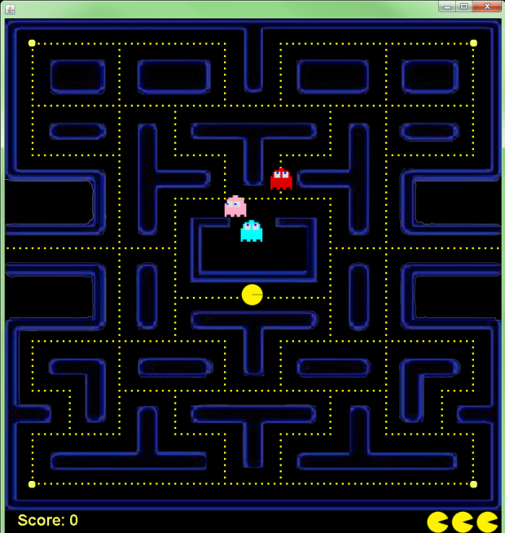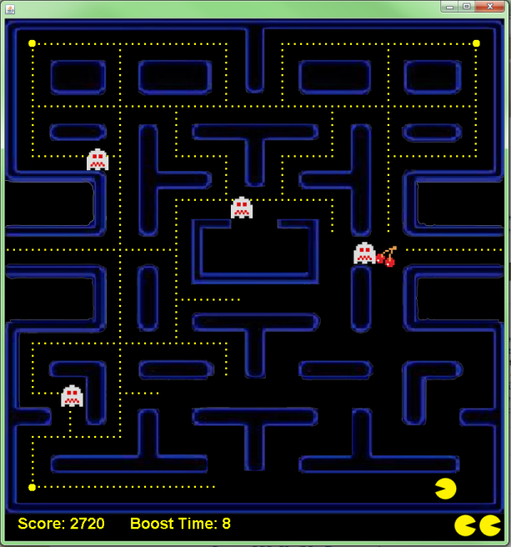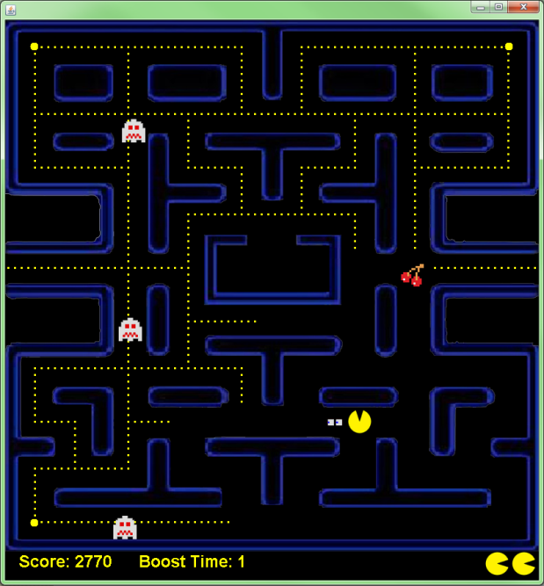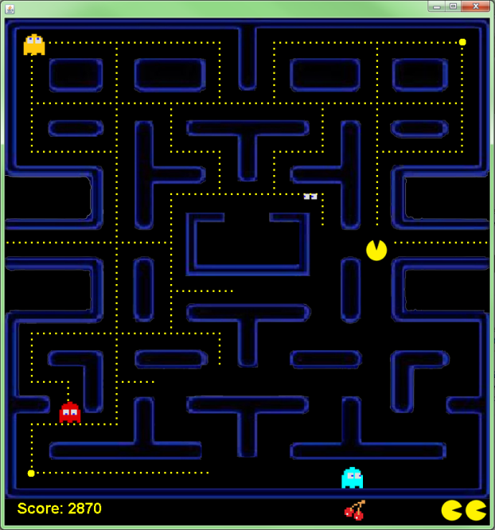

During the game, you collect points. The point score counter in bottom left corner will count up as you collect points. When you collect a certain number of points a cherry will appear. This cherry can be collected for bonus points. If you run into a ghost without the boost you will lose a life. Which is counted in the bottom right of the screen, the number of cherries collected is also counted at the bottom of the screen. Collecting the boost in each corner of the map will allow you to eat ghosts. There is a timer that shows how much time is left on the boost next to the score. Once a ghost is eaten when you have the boost, it will run back to its spawn box in the middle of the map and once it reaches it; it will respawn. The game will end once you have collected all the points or lost all your lives.

Once in the game you can press the [p] button to pause the game. Once the game is paused a pause menu will appear. In pause menu there is a resume, menu and exit button.

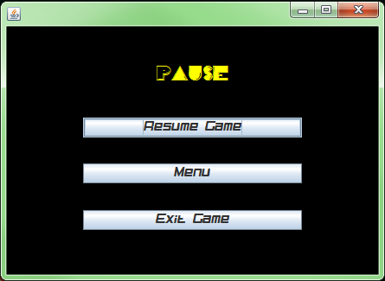

The resume button will close the pause screen and resume the game. The menu button will close the game and pause menu and open the menu.

Once the game end, the score screen will pop up. The score screen contains a leader board, menu and exit button.

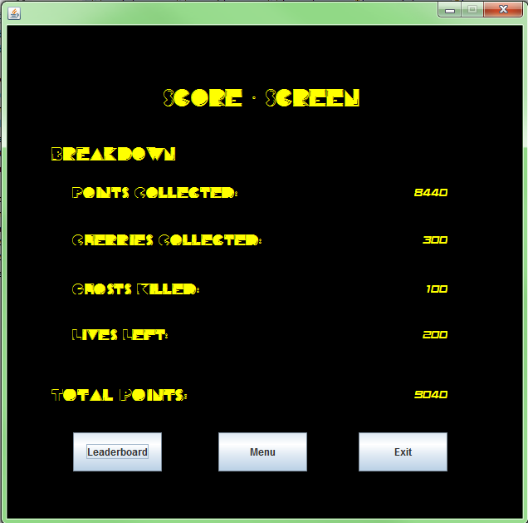

The menu button will bring you back to the menu and the leaderboard button will bring you to the leader. Identical to the leaderboard button on the menu.

Clicking the exit button on any of these frames will open this JOptionPane, confirming whether or not you want to exit the game.

